Charting Logic and Mapping Blackjack Program (Python)

Blackjack rules:

* User and Dealer purpose to get as close as possible to 21 or hit 21
* Cards available to draw for both user and dealer are [2-10, each worth their face value], [Face Cards: Jack, Queen, and King are each worth 10 big ones], and finally the Ace [Ace can be worth either 1 or 11 depending on which value benefits hand more]  
    
  **QUICK NOTE**  
  - *There are 4 suits per deck: Hearts, Diamonds, Clubs, and Spades.  
  - Each suit has 13 cards: numbered 2 through 10, plus Jack, Queen, King, and Ace. = 52 cards per deck*
* Dealer deals x2 cards to himself (1/2 of dealers cards are hidden) and x2 cards to player (none are hidden) cards to player,
* Scores are then gathered and displayed user sum = sum of both cards, and the dealer only displays one card, so their score is just the sum of the first card
* User is then asked if they would like to HIT or STAND
* *Hittin*g is when the user chooses to draw x1 card from the deck and check score to see how close score got to 21, hit 21, or passed 21.   
  Note: *if score passes 21 game ends and user loses.*
* *Stand* is when user decides to not draw a card and pass the turn to the dealer allowing dealer to hit or stand, and so on till the game ends.

*CODING STEPS*

Step 1: Make function for check_score (*also checks if for ace)*, draw, deal, stand, and Hit

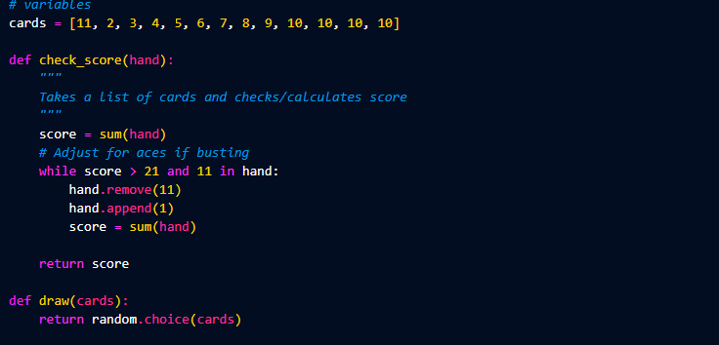

Step 2: make function play blackjack() function within it is :  
  
- Make empty dictionary for player and dealer and make both scores and set both scores to 0

- Deal x2 cards to player with deal(), and two to dealer with deal()

- Then use check score function to get sums for player & dealer  
  
- Then display both player hand score and dealer scores with f(f’ ’)

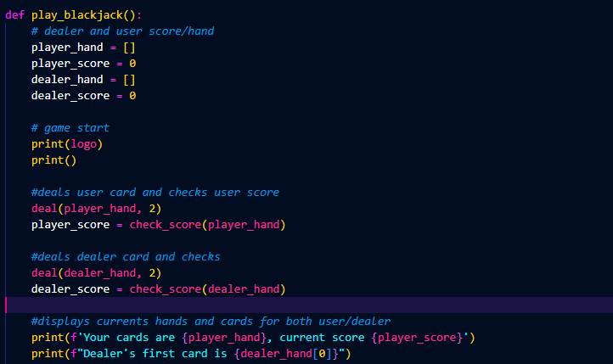

******************************************************************************************************

- Make a while true: for the player hit/stand loop

- Make input variable of option which asks if player wants to hit or stand

- if h is input then deal() x1 card to player hand then set new player score with check_score function

- Then display player and dealer score and player hand and the first card of dealer score [0]

- check if player_score > 21: if it is print(“bust”)

- make an elif so if player does stand just print(“player”, player_score) and then break out of the loop to go on to dealer code

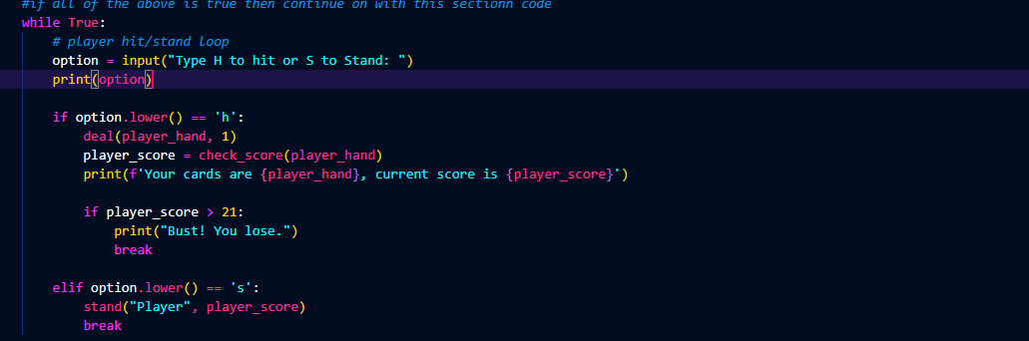

*\*\*\*\*\*\*\*\*\*\*\*\*\*\*\*\*\*\*\*\*\*\*\*\*\*\*\*\*\*\*\*\*\*\*\*\*\*\*\*\*\*\*\*\*\*\*\*\*\*\*\*\*\*\*\*\*\*\*\*\*\*\*\*\*\*\*\*\*\*\*\*\*\*\*\*\*\*\*\*\*\*\*\*\*\*\*\*\*\*\*\*\*\*\*\*\*\*\*\*\*\*\**

*- If player_score < 21:*

*While dealer_score < 17:*

- Then deal the dealer x1 card with the deal function and then check_score and display dealer score and hand

- check if dealer score > 21: if it is print(“Bust”) and break

- *if dealer_score > player_score print(“Dealer wins”)*

*elif dealer_score < player_score: print(“You Win”)*

*else: print(“It’s a tie”)*

- Step out of loop and make another while true asking if they want to replay if they do run the play_blackjack() again

